MISSION STATEMENT
The Helen Bass Williams Academic Success Center (ASC) provides undergraduate students with opportunities to develop transferable academic skills, enhance learning, increase retention and improve overall success throughout their academic journey.

VISION STATEMENT
The ASC aspires to provide all undergraduate students with services and opportunities to define and develop strategies that help them reach their goals. Driven by a focus on students, the ASC partners with the campus community to facilitate a culture of academic confidence, tenacity and — ultimately — success.

PROGRAM ELEMENTS
The Helen Bass Williams Academic Success Center offers free services that support students’ learning. Available in both West Lafayette and Indianapolis, these services focus on the process strategies and skills that support the content expertise provided in the classroom.

Figure 1: ASC Services by Type of Support and Location
 | WEST LAFAYETTE | INDIANAPOLIS
STUDY SKILLS DEVELOPMENT | - Peer Success Coaching  - Study Skills Consultations  - Workshops  - Online Resources  - Accountability Groups | - Peer Success Coaching  - Study Skills Consultations  - Workshops  - Online Resources
COURSE-SPECIFIC CONTENT SUPPORT | - Supplemental Instruction  - Test Drive | - Peer Tutoring  - Math Assistance Center Partnership

- The Peer Success Coaching program (PSC) offers students additional support, campus resources and connections, and accountability as they work toward academic, social and personal goals. Trained peer leaders work one-on-one with students to develop strategies, skills and solutions as they aim for their definition of success.
- Study Skills Consultations are individual meetings that provide students with tailored support on study strategies, time management, test-taking and other academic success topics. These one-on-one meetings with a staff member require an appointment. Participating students may voluntarily seek support or be required by an academic program or campus office to meet with a consultant.
- Workshops provide an interactive environment for small and large groups to identify and practice strategies for effective studying and learning, including time management, overcoming procrastination and effective studying. In addition to the ASC’s open series of workshops, student organizations and classes can also request workshops for their groups.
- Online resources are available to students and the campus community through the ASC website. These include success strategy handouts, a GPA calculator, and a searchable database of course-specific help rooms and tutoring programs available across campus.

West Lafayette-Specific Programs and Services
- The Supplemental Instruction (SI) program provides students with interactive, peer-led study sessions for traditionally challenging courses. Trained SI leaders facilitate group activities that encourage students to think critically about course material, apply concepts and learn transferable study skills. In the fall and spring semesters, SI was offered in 30+ courses with 45+ trained leaders. In the summer semester, SI was offered online for a limited number of courses.
- Accountability Groups offer students ongoing peer support during 90-minute weekly meetings with an established group of 8-10 peers plus an ASC facilitator. During group meetings, students discuss current academic challenges and successes, share strategies, set goals, and work on individual goals.
- Test Drive is a large-scale workshop that gives students in select high-enrollment, first-year chemistry, math and physics courses the opportunity to take a mock exam in Elliott Hall of Music. The program started in 2017 to address a common concern brought up by first-year students: They felt unprepared for their first exams because of how intimidating Elliott Hall of Music can be as an exam venue.

Indianapolis-Specific Programs and Services
- The Peer Tutoring program provides students with peer-led study sessions for traditionally challenging courses. Trained peer tutors facilitate individual and small group activities that encourage students to think critically about course material, apply concepts and learn transferable study skills. Students schedule appointments through BoilerConnect, creating more flexibility and more efficient use of tutoring resources.
- The Math Assistance Center (MAC) Partnership gives students access to the Indiana University Indianapolis Math Assistance Center for support in all math and statistics courses. In addition to utilizing the MAC, the ASC’s partnership also provides opportunities for students to work as MAC tutors. This partnership aims to provide a seamless academic support experience for students by adjusting schedules to match the Purdue semester calendar, using BoilerConnect for check-in and adding visible Purdue branding within the MAC space.

OUTCOMES
The Helen Bass Williams Academic Success Center has several categories for outcomes. While this report focuses on program outcomes, the ASC student employment outcomes and competencies along with the ASC student-facing learning outcomes are available in Appendix A and Appendix B.

As a result of participating in programs and services offered by the Helen Bass Williams Academic Success Center, students will:
- Achieve better course outcome (grade) than comparable peers who did not participate
- Be retained at a higher rate than peers who did not participate
- Complete more credit hours per semester than peers who did not participate
- Earn a higher GPA (term and cumulative) than peers who did not participate
- Maintain or return to good academic standing status (term and cumulative GPA at or above 2.0) at a higher rate compared to the overall university rate

ASSESSMENT PLANS
The Helen Bass Williams Academic Success Center assesses the outcomes of programs and services on an ongoing basis. In addition to current assessment plans, the ASC staff aspire to deepen their understanding of how programs and services influence students, student leaders, and campus. The ASC staff also aims to make scholarly contributions to the field of learning and academic support. Aspirational assessment and study ideas are available in Appendix C.

Semester Assessment
- Feedback survey to Supplemental Instruction participants about session experience
- Feedback survey to Peer Success Coaching participants about coaching experience
- Feedback survey to participants post-workshop (after each session)
- BoilerConnect metrics (case referrals, hand raises, and strategic campaigns)
- ASC space utilization
- [In Progress] Pre- and post-survey for Accountability Group participants
- [In Progress] Study Skills Consultation evaluation/feedback
- Standard GPA, standing, course grade (where relevant), retention, etc. reporting for SI, PSC, consultations, and accountability groups
- [Aspirational] Sense of Belonging measurement embedded into each program’s semester assessment

Annual Assessment
- Student leader performance evaluations on competencies
- [New] Student leader feedback on supervising staff performance
- [New] Course sequencing ANCOVA for specific SI courses
- [Aspirational] Intersectional reporting of current data and metrics (Are we reducing, maintaining or exacerbating a gap in equity?)

Rotational Assessment and Studies
- Impact of Attending SI Accounting for Self-Selection Bias (study using propensity score matching to evaluate participant and non-participant course outcomes)
- Qualitative study on the experience of serving as PSC related to skill development
*See Dufault, K.H. (2023). Peer learning experiences of undergraduate academic coaches. The Learning Assistance Review, 28(2), 1-42. https://nclca.wildapricot.org/resources/Documents/TLARVolume28%202Fall2023.pdf
- [Proposed] Impact of Study Skills Consultations (explore outcomes of referral cases comparing students who meet with a consultant to students who do not meet with a consultant; understand student experience of meeting with a consultant; identify the values and influences of academic consultations from their perceptive, beyond university metrics)

NOTABLE CHANGES
- Program Updates
  - Test Drive 2025 expanded the post-mock exam options to include a “non-content” exam for students who have exams in Elliott Hall of Music for a course that was not participating.
    - For 2026, Elliott Hall of Music will be closed for renovations so Test Drive event will be paused.
  - In Summer 2024, the ASC renamed “academic consultations” to “study skills consultations.” This was an effort to provide more clarity to students on what to expect during consultations so they are not confused with academic advising appointments.
  - In August 2025, the university updated its contract with EAB Navigate (used as BoilerConnect) to include the student-facing app and related features. The ASC participated in strategic outreach following the Intake Survey results and select course progress reports as well as campaign follow-up for students who self-refer using the “hand-raise” option.

- Partnerships
  - Onboarding New Student Efforts: The ASC continued to collaborate with Orientation Programs on the development and facilitation of Academic Success sessions with a customized session for Indianapolis.
  - Academic Notice Support: The ASC continued to work with campus partners in Teaching and Learning and the Office of the Dean of Students on outreach efforts for students on academic notice for the first or second semester with a mirrored process for students in Indianapolis. Indianapolis piloted having peer success coaches provide some of the message outreach for first-year students on notice in Spring 2025. This academic year, we have moved the messages into BoilerConnect as a campaign with full messages available on the ASC website.
  - UIA Academic Recovery Grant: In Summer 2024, the ASC director became the principal investigator for the University Innovation Alliance (UIA) Academic Recovery Grant and project. Going into its second year, the project aims to support students who need to retake a course that is critical to program progression. In Fall 2024, the project piloted a proactive academic support approach in courses with high DFW rates by providing targeted messaging and micro-incentives for engaging in the ASC’s services. In Spring 2025, we provided a scholarship for x students who were retaking MA 153 as well as continued the micro-inventive approach for all students enrolled in MA 153. In Summer 2025 and Fall 2025, the ASC will be working with math education faculty to develop mathematic mindset modules aimed at supporting students’ growth mindset and learning strategies for math.
  - Add in updates to BoilerConnect – progress reports, hand raises, app, journeys

- Staffing
  - With the first year in Indianapolis, the ASC services grew and Jo Cardarelli was promoted from assistant director to associate director and site lead for Indianapolis to better reflect her responsibilities. In addition to being part of the ASC team, the associate director serves as part of the Teaching and Learning team in Indianapolis with a dotted reporting line to the Executive Director of Teaching and Learning Programs in Indianapolis.
  - A program coordinator vacancy in February 2025 allowed a shift in program coordinator responsibilities so that all three positions are responsible for coordinating a student leader position and related program (SI Leaders, SOAs, and PSCs). The associate director who had previously supervised the PSC program shifted responsibilities to manage center-level activity including the joint student leader hiring process, senior leader committees, and training and development efforts. A new program coordinator was hired to support the PSC program and began in June 2025.
  - Two graduate assistants (GAs) returned from the 2023-2024 academic year, and two new GAs joined the team in August 2024.

- Purdue University in Indianapolis
  - In August 2025, the ASC moved to the newly acquired Student Center (520 Indiana Ave) building, gaining a space for student leaders.
  - A .25 graduate assistant was assigned to Indianapolis.
  - The ASC student leader positions include:
    - Academic Success Ambassadors (ASAs) that promote academic success in Indianapolis through a variety of efforts, including providing Peer Success Coaching, tabling and outreach, and leadership to other student leaders in Indianapolis. ASAs work on projects, such as social media, training and development, and observations. The ASC is no longer hiring new ASAs, shifting instead to Peer Success Coaches and moving toward a senior leader model.
    - Peer Success Coaches (PSCs) provide 1-on-1 support for academic, personal, and social goals. They provide accountability, resource navigation, and strategy support. The program has grown to include 4 PSCs in addition to 6 ASAs still providing coaching, too.
    - Peer Tutors that provide appointment-based tutoring sessions for individuals and small groups enrolled in gateway STEM courses. The program has expanded to include 20 tutors supporting 40 courses across all represented colleges in Indianapolis.
    - MAC Tutors that functionally report in the IUI Math Assistance Center but are employed through the ASC.
  - The ASC piloting tutoring campaign outreach to students enrolled in 5 courses in College of Science (PHYS 172, PHYS 272, CHM 11510, CS 159, CS 180). For AY 25-26, this will become a strategic outreach to students based on instructor feedback through BoilerConnect Progress reports.
  - In addition to the general updates to BoilerConnect mentioned above, Indianapolis has piloted Student Journeys, with the ASC providing content for a Study Skills Journey that students can be assigned or self-select to complete.

Appendix A.

ASC VALUES
Our efforts and interactions in the Academic Success Center are guided by and should reflect our shared values of:
- Collaboration + Interdependence
- Innovation | Reflection | Growth
- Fun
- Intentionality + Purpose
- Empowering Students (Community | Empathy | Servant Leadership | Student-Centered)

ASC STUDENT LEADER COMPETENCIES
As a result of employment with the ASC, student leaders will develop skills and knowledge related to the five Student Leader Core Competencies:

1. Reflective Problem Solving
- Engage in ongoing self-reflection to identify problems, challenges and areas of growth
- Develop awareness of how values and ethics influence decision-making
- Employ critical, practical and creative thinking skills to generate possible solutions or strategies for improvement
- Use feedback to strengthen problem-solving skills

2. Effective Communication
- Demonstrate effective verbal, non-verbal, and written communication skills to share ideas and information effectively Employ active listening skills and interpersonal awareness to build trust and support effective communication Assess situations, process information and respond appropriately
- Adapt messaging to ensure clarity for the intended audience and context

3. Professionalism
- Represent the Academic Success Center and its values with integrity and authenticity
- Engage in respectful interactions with peers, students, staff and faculty members
- Enthusiastically seek, embrace and implement constructive feedback from peers, mentors and supervisors
- Strive for continued personal and professional growth

4. Initiative
- Take ownership of all responsibilities and timelines
- Pursue new projects and proactively find areas to contribute to the department
- Use feedback and previous experience to anticipate needs and performance adjustments
- Exhibit resourcefulness, independent action and professional judgment that are position-appropriate

5. Collaborative Leadership
- Create and contribute to learning environments where peers feel comfortable contributing & growing
- Demonstrate flexibility by adapting your approach to support varied learning needs and engagement styles
- Establish trust and maintain productive relationships with students, peers, supervisors, and campus partners
- Reflect on how your actions as a peer leader impact the learning experiences of others

These competencies are woven throughout the student leader experience as selection criteria, training outcomes and topics, and evaluation benchmarks.

ASC PROFESSIONAL STAFF CORE COMPETENCIES
Like our student leaders, our professional staff aim to possess and strengthen the following competencies:
- Problem-Solving
- Self-Awareness and Development
- Productive Relationships
- Community
- Effective Communication

Appendix B.

STUDENT-FACING LEARNING OUTCOMES
The following outcomes were written with the student audience in mind and answer the questions posed by Fink (2013):
“…what kind of impact would you most like to have on your students? That is, when the course is over and it is now one or two years later, what would you like to be true about students who have participated in your courses that is not true of others? What is the distinctive educational impact you would like for your teaching and your courses to have on your students?” (p. 10)

As a result of participating in programs and services offered by the Academic Success Center, students will:
- Engage with peers to problem-solve and increase learning
- Identify and utilize relevant ASC services and campus resources to achieve their goals
- Identify, explain and implement strategies for effective studying and learning
- Evaluate and adapt study plans and strategies to address changes and challenges in meeting learning goals and needs
- Assess strengths and areas in need of improvement in academic skills and course content
- Gain transferable strategies for future semesters with increasingly rigorous material and a career after graduation
- Demonstrate stronger learning comprehension as measurable by course grade(s)
- Develop critical thinking skills beyond memorization
- Achieve better course outcome (grade) than comparable peers who did not participate
- Maintain or return to good academic standing status (term and cumulative GPA at or above 2.0)
- Increase self-efficacy and confidence in academic setting and performance

These learning outcomes are assessed differently depending on the service. Most are informal and formative assessments conducted during sessions via activities and assignments, exiting prompts, and end-of-semester surveys.

Appendix C.

ASPIRATIONAL ASSESSMENT AND STUDIES
The ASC staff aspires to continuously explore the effectiveness of our work, understand its impact from a variety of perspectives and contribute to the scholarship of teaching and learning. We would like to address the following research questions and ideas:
- Qualitative study on Supplemental Instruction participant experiences (Does it make a difference from their perspective? Other values or influence beyond university metrics? Culture of sessions? Motivation for attending?)
- Qualitative study on students in SI-linked courses who do not utilize SI (What are the barriers? What is their understanding and perception of SI?)
- Qualitative study on Peer Success Coaching participant experiences (Does it make a difference from their perspective? Other values or influence beyond university metrics? Motivation for signing up? Motivation for continuing to meet with a PSC?)
- Mixed methods study into Accountability Groups (Investigate sense of belongingness, SRL (co-regulated?), and academic emotions; What are their experiences of having psychoeducational support via weekly groups?)
- Campus Awareness of ASC with a variety of stakeholder groups, including advisors, faculty/instructors and students (multiple groups)
- Student experiences and outcomes with campus-wide academic support programs and services
- Short-term vs. long-term effects of academic support
- Comparison of student leader experiences to those of students served by the ASC programs (consider their academic emotions, SRL strategies, sense of belongingness, etc.)
- Influence of student leader representation for students in SI-linked courses (Does the leader’s identities influence who attends SI sessions? Outcomes of students overall and with similar identities)
- Student leaders’ metacognition and SRL strategy changes over time serving in student leader role
- Student utilization of multiple ASC services versus single service (What motivates students to use different services and/or multiple services? What is the student’s awareness of all of the ASC services when they are engaged in one ASC offering? How does using multiple services impact the students’ experience and outcomes?)
- Influence of working as an ASC graduate assistant and academic consultant on graduate students’ academic experience and strategies

Appendix D.

2024-25 ACADEMIC SUCCESS CENTER DATA
In the 2024-25 academic year, the Academic Success Center offered Supplemental Instruction, Peer Success Coaching, Academic Consultations, Workshops, Accountability Groups, Peer Tutoring, and Study Space. A total of 6,556 students utilized the Academic Success Center’s services in the 2024-25 academic year. The charts below show the distribution of how many programs students participated in.

2024-25 ACADEMIC SUCCESS CENTER DATA BY LOCATION – WEST LAFAYETTE

2024-25 ACADEMIC SUCCESS CENTER DATA BY LOCATION – WEST LAFAYETTE

SUPPLEMENTAL INSTRUCTION (WL)
Fall 2024 SI Attendance
Of those who attended SI eight or more times, 95% earned a C or better, 75% earned a B or better, and 39% earned an A. The DFW rate was 12% higher for those who never attended when compared to those who attended eight or more times. Of students enrolled in SI-eligible courses, approximately 21% participated in SI.

 | No Sessions | 1-2 Sessions | 3-4 Sessions | 5-7 Sessions | 8+ Sessions
A | 34% | 37% | 38% | 29% | 39%
B or better | 64% | 70% | 70% | 68% | 75%
C or better | 83% | 89% | 92% | 89% | 95%
DFW | 17% | 11% | 8% | 11% | 5%
Total Students | 24,197 | 3,483 | 589 | 179 | 291

Spring 2025 SI Attendance
Of those who attended SI eight or more times, 92% earned a C or better, 71% earned a B or better, and 42% earned an A. The DFW rate was 9% higher for those who never attended when compared to those who attended eight or more times. Of students enrolled in SI-eligible courses, approximately 18% participated in SI.

 | No Sessions | 1-2 Sessions | 3-4 Sessions | 5-7 Sessions | 8+ Sessions
A | 35% | 36% | 40% | 33% | 42%
B or better | 64% | 68% | 73% | 67% | 71%
C or better | 83% | 90% | 92% | 91% | 92%
DFW | 17% | 10% | 8% | 9% | 8%
Total Students | 19,766 | 2,285 | 415 | 126 | 269

Retention Data
- For the 2019 cohort, the six-year graduate rate is 8.12% higher for students who attended one or more SI sessions their first year than for students who did not attend SI their first year.
- For the 2024 cohort, the one-year retention rate is 8.57% higher for students who attended one or more SI sessions than for students who did not attend SI.
Table 1: FTFT Retention and Graduation Rates by SI/Non-SI (for students who attended SI in first year)
Academic Year | Cohort |  | One-Year Retention Rate | Two-Year Retention Rate | Three-Year Retention Rate | Four-Year Graduation Rate | Five-Year Graduation Rate | Six-Year Graduation Rate
2011 | SI | 989 | 95.15% | 90.80% | 87.56% | 56.32% | 82.20% | 87.06%
2011 | Non-SI | 5671 | 89.77% | 83.21% | 79.79% | 50.64% | 72.79% | 77.29%
2012 | SI | 1478 | 94.38% | 90.80% | 88.36% | 59.54% | 81.80% | 86.60%
2012 | Non-SI | 4851 | 89.98% | 84.66% | 81.26% | 54.73% | 75.74% | 79.53%
2013 | SI | 1799 | 95.11% | 91.50% | 87.27% | 57.75% | 80.04% | 85.77%
2013 | Non-SI | 4520 | 91.64% | 86.17% | 81.99% | 58.83% | 77.39% | 80.77%
2014 | SI | 1312 | 95.05% | 92.61% | 88.64% | 63.41% | 81.71% | 88.49%
2014 | Non-SI | 5096 | 92.17% | 86.85% | 82.81% | 59.44% | 78.63% | 81.93%
2015 | SI | 2451 | 94.37% | 90.58% | 87.43% | 62.50% | 82.62% | 87.07%
2015 | Non-SI | 4404 | 90.30% | 85.42% | 80.52% | 59.47% | 77.09% | 80.79%
2016 | SI | 2432 | 94.24% | 91.69% | 87.83% | 64.84% | 83.10% | 88.16%
2016 | Non-SI | 4797 | 90.33% | 85.28% | 80.55% | 61.52% | 77.92% | 81.15%
2017 | SI | 2782 | 95.26% | 92.34% | 89.07% | 67.97% | 85.77% | 89.58%
2017 | Non-SI | 4766 | 90.01% | 85.14% | 79.58% | 63.28% | 77.61% | 80.47%
2018 | SI | 2973 | 95.19% | 92.06% | 89.24% | 70.06% | 87.25% | 89.61%
2018 | Non-SI | 5355 | 89.56% | 84.86% | 79.01% | 63.08% | 76.96% | 80.13%
2019 | SI | 2482 | 96.41% | 92.87% | 88.32% | 71.15% | 86.91% | 90.21%
2019 | Non-SI | 5529 | 92.26% | 85.75% | 79.63% | 64.57% | 78.46% | 82.09%
2020 | SI | 958 | 95.51% | 93.01% | 87.68% | 74.32% | 86.53%
2020 | Non-SI | 7820 | 91.10% | 86.21% | 80.84% | 66.28% | 79.86%
2021 | SI | 2805 | 95.97% | 92.66% | 88.77% | 74.72%
2021 | Non-SI | 7337 | 88.66% | 84.52% | 78.96% | 65.91%
2022 | SI | 3778 | 95.55% | 93.73% | 88.67%
2022 | Non-SI | 5497 | 90.01% | 86.12% | 77.77%
2023 | SI | 2881 | 97.05% | 94.79%
2023 | Non-SI | 6341 | 90.95% | 87.23%
2024 | SI | 3426 | 95.97%
2024 | Non-SI | 7863 | 91.03%

History of Courses, Leaders, Visits and Unique Students

PEER TUTORING (INDY)
The Peer Tutoring program launched during week 6 of the inaugural Fall 2024 semester of Purdue University in Indianapolis. Over the academic year, the program expanded to support more courses.

 | Fall 2024  (Week 6-16) | Spring 2025 | 2024-25 Total
# of Visits Total | 101 | 391 | 492
Unique Students Served total | 54 | 99 | 137
# of Courses | 13 | 20 | 28

Fall 2024 | No Sessions | 1 Session | 2 Sessions | 3+ Sessions
A | 62% | 24% | 33% | 44%
B or better | 72% | 58% | 78% | 67%
C or better | 75% | 87% | 100% | 100%
DFW | 25% | 13% | 0% | 0%
Total Grades | 3,342 | 38 | 9 | 9

Spring 2025 | No Sessions | 1 Session | 2 Sessions | 3+ Sessions
A | 64% | 24% | 25% | 22%
B or better | 73% | 52% | 63% | 54%
C or better | 76% | 78% | 94% | 84%
DFW | 24% | 22% | 6% | 16%
Total Grades | 2,949 | 63 | 16 | 37

Demographic Information of Students Served Through Peer Tutoring (with All Purdue (INDY) Reference Lines)

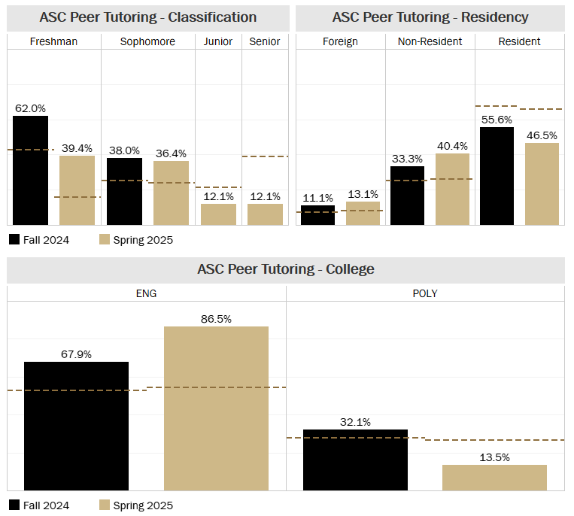

CONSULTATIONS (WL & INDY)
During the 2024-25 academic year, the ASC held a total of 523 consultations for 429 unique students.
 | Fall 2024 | Spring 2025 | 2024-25 Total
WL Consultations | 275 | 212 | 487
Indy Consultations | 13 | 25 | 38
# of Visits Total | 288 | 235 | 523
WL Unique Students | 236 | 176 | 401
Indy Unique Students | 12 | 19 | 29
Unique Students Served total | 248 | 194 | 429

Demographic Information of Students Served Through Consultations (with All Purdue Reference Lines)
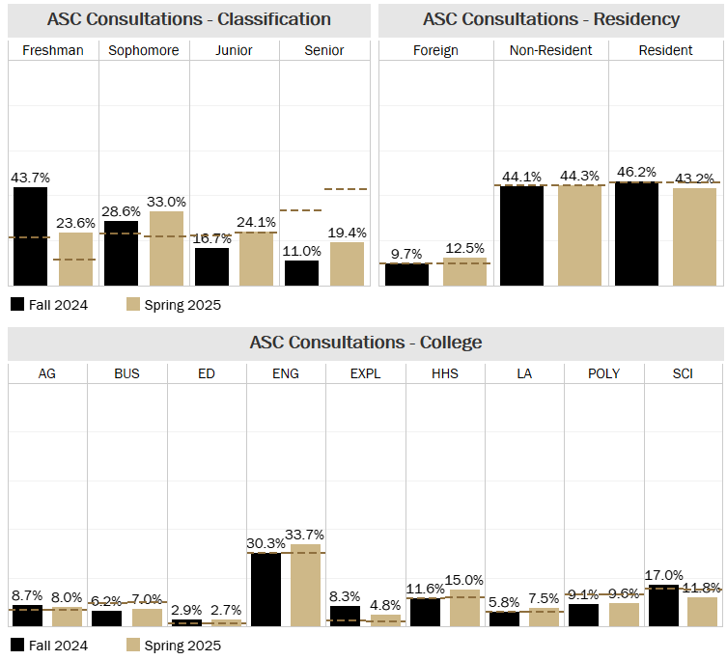
Academic Standing of Students Served Through Consultations
One outcome the ASC aims to reach with academic consultations is that participating students will “maintain or return to good academic standing status (term and cumulative GPA at or above 2.0).” When looking at the outcome of a semester’s academic standing, it is helpful to consider the academic standing participating students were in during the semester they received support. For students in good standing, the goal is to maintain their academic good standing. For students on academic notice, the ideal goal is to earn a cumulative and term GPA of 2.0+ so they can return to good standing. However, depending on the student’s cumulative GPA, it may not be mathematically possible to return to good standing in just one semester. In these situations, remaining on notice is a neutral to positive outcome. For all students, being academically separated is not the desired outcome.

The charts below show the academic standing outcomes of participating students versus all Purdue students based on their standing groups during the semester. In Fall 2024, 86.6% of participating students who were in good standing when seeking support remained in good standing at the end of the term. That same semester, 53.2% of participating students who were on academic probation during the semester of support returned to academic good standing. In Spring 2025, 54.8% of students who were on probation during the semester of support returned to academic good standing.
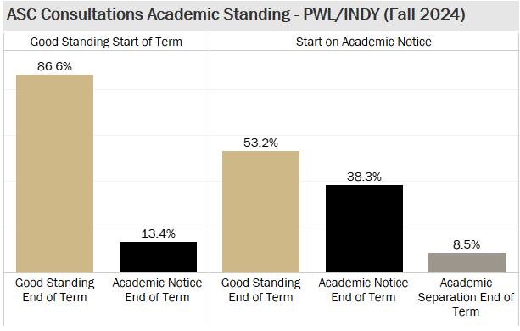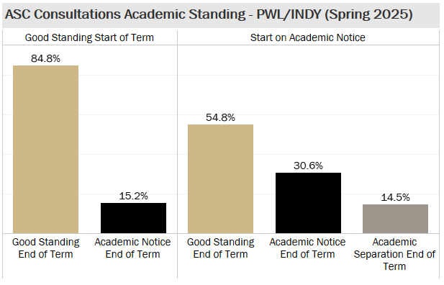

Average GPAs of Participating Students 2024-25
 | Fall 2024 | Spring 2025
Average Cumulative GPA | 2.92 | 2.82
Average Term GPA | 2.81 | 2.66
Average Credit Hours Completed | 12.98 | 13.03

PEER SUCCESS COACHING PROGRAM (WL & INDY)
During the 2024-25 academic year, the PSC program served 197 unique students and conducted 1,795 meetings.
 | Fall 2024 | Spring 2025 | 2024-25 Total
Visits | 827 | 968 | 1,795
Visits in WL | 730 | 825 | 1,555
Visits in Indy | 97 | 143 | 240
Unique Students Served | 117 | 137 | 197
Unique…WL | 104 | 116 | 169
Unique… Indy | 13 | 21 | 28

Demographics of PSC Program Participants (with All Purdue Reference Lines)
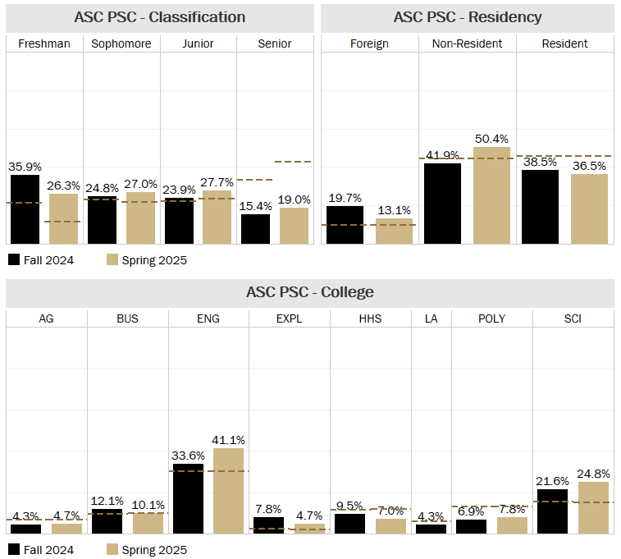
Additional PSC Data
The table below shows that in the 2024-25 academic year, students met with their Peer Success Coach an average of 10 times per semester. The minimum number of visits is 1 and the maximum is 32.

N | Minimum | Maximum | Mean | Std. Deviation
135 | 1 | 32 | 9.1 | 4.05

The table below shows the end-of-semester academic standing for PSC participants who were on academic notice at the beginning of the semester.

 | End-of-Semester Standing
 | Good Standing | Academic Notice | Academic Separation
Fall 2024 Notice Students (N=21) | 66.7% | 28.6% | 4.8%
Spring 2025 Notice Students (N=43) | 53.5% | 32.6% | 14.0%

ACCOUNTABILITY GROUPS (WL)
In Fall 2021, the ASC began hosting Accountability Groups. This program offers ongoing support to undergraduate students in a group setting to help them strengthen their study skills and stay motivated.

 | Fall 2024 | Spring 2025 | 2024-25 Total
# of Visits | 778 | 595 | 1373
Unique Students Served | 150 | 104 | 229

Demographic Information of Students Served Through Accountability Groups (with All Purdue Reference Lines)
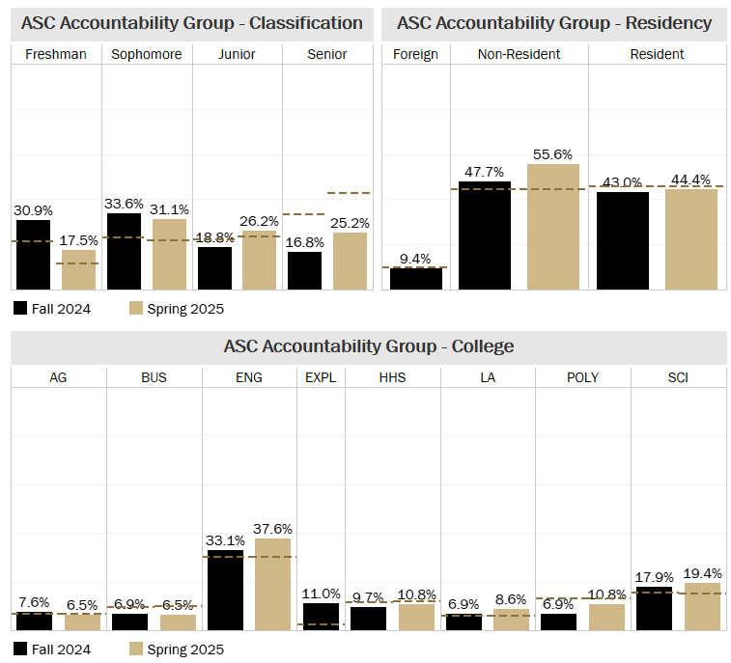

Average GPAs of Participating Students 2024-25
 | Fall 2024 | Spring 2025
Average Cumulative GPA | 2.99 | 2.96
Average Term GPA | 2.85 | 2.96
Average Credit Hours Completed | 13.72 | 13.83

ASC STUDY SPACE VISITS (WL)
In Fall 2024 and Spring 2025, 740 unique students checked into the Academic Success Center in West Lafayette for general purposes or to attend ASC leader office hours.
ASC Study Space
 | Fall 2024 | Spring 2025 | 2024-25 Total
# of Visits | 2,287 | 2,393 | 4,680
Unique Students Served | 481 | 388 | 729

ASC Leader Office Hours
 | Fall 2024 | Spring 2025 | 2024-25 Total
# of Visits | 1,278 | 1,353 | 2,631
Unique Students Served | 86 | 73 | 110

Average GPAs of Checked In Students 2024-25
 | Fall 2024 | Spring 2025
Average Cumulative GPA | 3.59 | 3.60
Average Term GPA | 3.52 | 3.55
Average Credit Hours Completed | 15.08 | 14.52

Demographic Information of Students Who Checked into the ASC (with All Purdue Reference Lines)

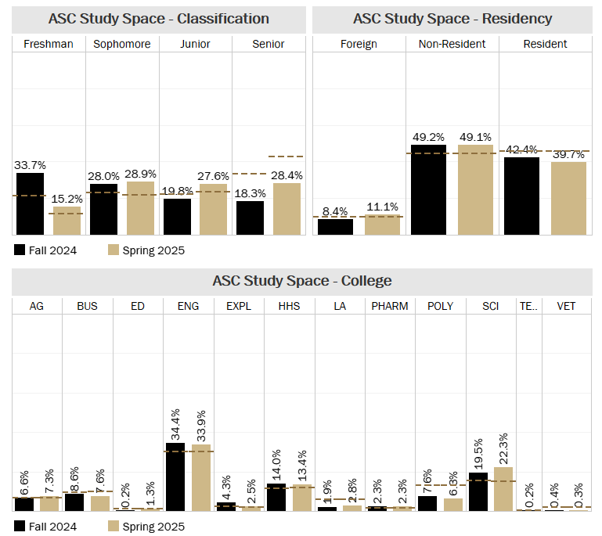

ASC WORKSHOPS
The ASC offers interactive and engaging workshops on various academic skills that help students address some of their most pressing challenges. Workshops are facilitated by professional staff and Student Office Ambassadors. They are offered throughout the semester in the ASC space and can be requested by faculty and student organizations. Custom workshops can also be requested. All workshops include a brief overview of ASC services and resources.
The workshops offered during the 2024-25 academic year include:
- Plan Your Successful Semester
- Choose Your Own Semester
  - Activity was implemented on a large-scale during Boiler Gold Rush and Boiler Cold Rush programs.
- Resource Roadmap (new Fall 2024)
- P.A.S.S. Your Exams
- Improve Your Reading & Notetaking
- Enhance Your Study Skills
- Maximize Your Time
- Finish Line Focus (new Fall 2024)
- Practice Your POMO
  - Late night, study event. Cannot be requested.
  - Only workshop offered in Indianapolis
- Create Your Finals Game Plan
  - New content/activities were implemented.
Requested Workshops
Workshop requests can be made by faculty, staff and student organizations throughout the year. During the 2023-24 academic year, the ASC received 83 workshop requests, representing an 8% increase in requests from the previous year. The ASC reached an estimated 3,463 students through these requested workshops. September is consistently the most popular month for requested workshops, and the three most requested workshops are Enhance Your Study Skills (18%), Maximize Your Time (17%), and Create Your Finals Game Plan (16%).
ASC Hosted Workshops
The ASC hosted 17 workshops during the 2024-25 academic year. Workshops served 231 unique students through a total of 264 workshop visits.
Average GPAs of Checked-In Workshop Attendees 2024-25
 | Fall 2024 | Spring 2025
Average Cumulative GPA | 3.30 | 3.14
Average Term GPA | 3.25 | 3.06
Average Credit Hours Completed | 13.81 | 14.56

Demographic Information of Students Who Checked into ASC Workshops (with All Purdue Reference Lines)
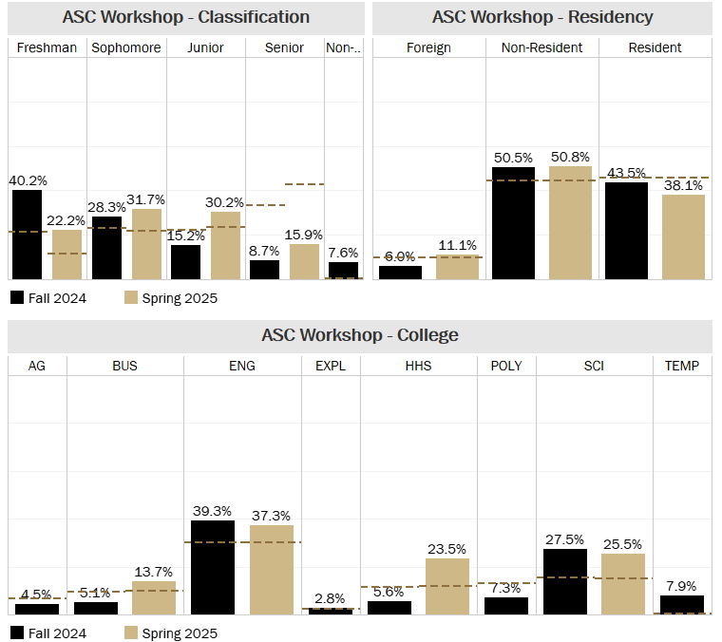

STUDENT LEADERS
Many of the ASC’s programs and services utilize undergraduate peer leaders to facilitate learning and support. The ASC staff aims to have a team of student leaders that represent diverse academic college and departments, demographics, and experiences. The ASC staff is invested in not only the learning outcomes of students supported through the programs and services but also the learning outcomes and development of the student leaders employed by the ASC.
Semester | WL | Indy | Total
Fall 2024 | 81 | 14 | 95
Spring 2025 | 81 | 25 | 106
Grand Total | 95 | 25 | 120
Average GPAs of Student Leaders 2024-25
 | Fall 2024 | Spring 2025
Average Cumulative GPA | 3.70 | 3.73
Average Term GPA | 3.62 | 3.66
Average Credit Hours Completed | 15.21 | 14.80

Demographic Information of Student Leaders (with All Purdue Reference Lines)
